Unit–III
Software Design: Overview of the design process, How to characterize a good software design? Layered arrangement of modules, Cohesion and Coupling, approaches to software design.
Agility: Agility and the Cost of Change, Agile Process, Extreme Programming (XP), Other Agile Process Models, Tool Set for the Agile Process (Text Book 2)
Function-Oriented Software Design: Overview of SA/SD methodology, Structured analysis, Developing the DFD model of a system, Structured design, Detailed design, and Design Review.
User Interface Design: Characteristics of a good user interface, Basic concepts, Types of user interfaces, Fundamentals of component-based GUI development, and user interface design methodology.

During the software design phase, the design document is produced, based on the customer requirements as documented in the SRS document. We can state the main objectives of the design phase, in other words, as follows.
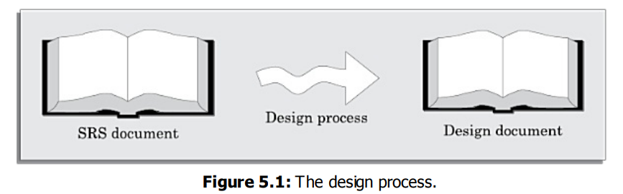
OVERVIEW OF THE DESIGN PROCESS
The design process essentially transforms the SRS document into a design document. In the following sections and subsections, we will discuss a few important issues associated with the design process.
- Outcome of the Design Process
The following items are designed and documented during the design phase.
Different modules required: The different modules in the solution should be clearly identified. Each module is a collection of functions and the data shared by the functions of the module
Control relationships among modules: A control relationship between two modules essentially arises due to function calls across the two modules.
Interfaces among different modules: The interfaces between two modules identifies the exact data items that are exchanged between the two modules when one module invokes a function of the other module.
Data structures of the individual modules: Each module normally stores some data that the functions of the module need to share to accomplish the overall responsibility of the module.
Algorithms required to implement the individual modules: Each function in a module usually performs some processing activity. The algorithms required to accomplish the processing activities of various modules need to be carefully designed and documented with due considerations given to the accuracy of the results, space and time complexities.
- Classification of Design Activities
A good software design is seldom realised by using a single step procedure, rather it requires iterating over a series of steps called the design activities.
Depending on the order in which various design activities are performed, we can broadly classify them into two important stages.
• Preliminary (or high-level) design, and
• Detailed design.
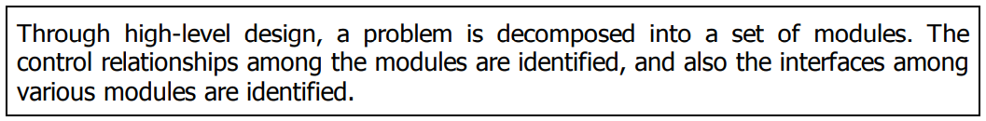

The outcome of high-level design is called the program structure or the software architecture. High-level design is a crucial step in the overall design of a software. When the high-level design is complete, the problem should have been decomposed into many small functionally independent modules that are cohesive, have low coupling among themselves, and are arranged in a hierarchy

The outcome of the detailed design stage is usually documented in the form of a module specification (MSPEC) document. After the high-level design is complete, the problem would have been decomposed into small modules, and the data structures and algorithms to be used described using MSPEC and can be easily grasped by programmers for initiating coding.

HOW TO CHARACTERISE A GOOD SOFTWARE DESIGN?
An accurate characterisation of a good software design that would hold across diverse problem domains is certainly not easy. In fact, the definition of a “good” software design can vary depending on the exact application being designed.

However, most researchers and software engineers agree on a few desirable characteristics that every good software design for general applications must possess. These characteristics are listed below:

Correctness: A good design should first of all be correct. That is, it should correctly implement all the functionalities of the system.
Understandability: A good design should be easily understandable. Unless a design solution is easily understandable, it would be difficult to implement and maintain it.
Efficiency: A good design solution should adequately address resource, time, and cost optimisation issues.
Maintainability: A good design should be easy to change. This is an important requirement, since change requests usually keep coming from the customer even after product release
- Understandability of a Design: A Major Concern
While performing the design of a certain problem, assume that we have arrived at a large number of design solutions and need to choose the best one.
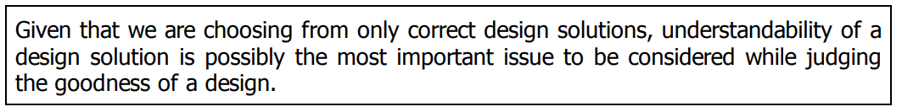
- Unless a design solution is easily understandable, it could lead to an implementation having a large number of defects and at the same time tremendously pushing up the development costs.
- Therefore, a good design solution should be simple and easily understandable.
- A design that is easy to understand is also easy to develop and maintain. A complex design would lead to severely increased life cycle costs.
- Unless a design is easily understandable, it would require tremendous effort to implement, test, debug, and maintain it.
An understandable design is modular and layered
To be able to compare the understandability of two design solutions, we should at least have an understanding of the general features that an easily understandable design should possess.
A design solution should have the following characteristics to be easily understandable:
- It should assign consistent and meaningful names to various design components.
- It should make use of the principles of decomposition and abstraction in good measures to simplify the design.

Modularity
- A modular design is an effective decomposition of a problem. It is a basic characteristic of any good design solution.
- A modular design, in simple words, implies that the problem has been decomposed into a set of modules that have only limited interactions with each other.
- Decomposition of a problem into modules facilitates taking advantage of the divide and conquer principle.
- If different modules have either no interactions or little interactions with each other, then each module can be understood separately
A software design with high cohesion and low coupling among modules is the effective problem decomposition
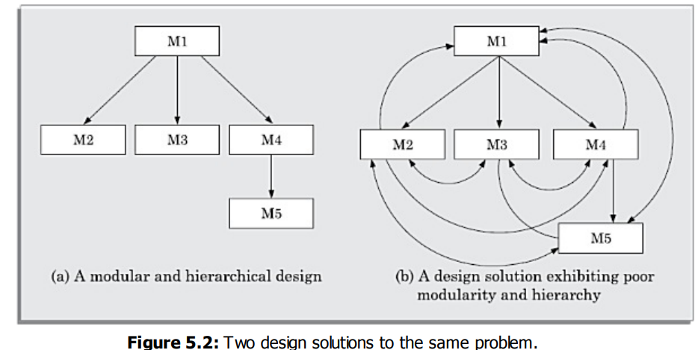
Based on this classification, we would be able to easily judge the cohesion and coupling existing in a design solution. From a knowledge of the cohesion and coupling in a design, we can form our own opinion about the modularity of the design solution.

Layered design
A layered design is one in which when the call relations among different modules are represented graphically, it would result in a tree-like diagram with clear layering.
In a layered design solution, the modules are arranged in a hierarchy of layers. A module can only invoke functions of the modules in the layer immediately below it.

A layered design can make the design solution easily understandable, since to understand the working of a module, one would at best have to understand how the immediately lower layer modules work without having to worry about the functioning of the upper layer modules.

When a failure is detected while executing a module, it is obvious that the modules below it can possibly be the source of the error. This greatly simplifies debugging since one would need to concentrate only on a few modules to detect the error.

COHESION AND COUPLING
Cohesion is a measure of the functional strength of a module, whereas the coupling between two modules is a measure of the degree of interaction (or interdependence) between the two modules.
If two modules either do not interact with each other at all or at best interact by passing no data or only a few primitive data items, they are said to have low coupling.

Cohesion: When the functions of the module co-operate with each other for performing a single objective, then the module has good cohesion. If the functions of the module do very different things and do not co-operate with each other to perform a single piece of work, then the module has very poor cohesion.

Classification of Cohesiveness
Cohesiveness of a module is the degree to which the different functions of the module co-operate to work towards a single objective.
The different modules of a design can possess different degrees of freedom. However, the different classes of cohesion that modules can possess are depicted in Figure 5.3.
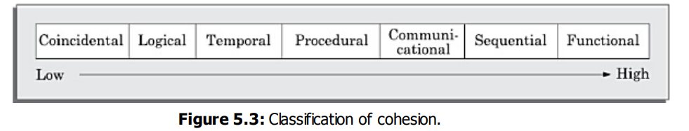
Coincidental cohesion: A module is said to have coincidental cohesion, if it performs a set of tasks that relate to each other very loosely, if at all.
Logical cohesion: A module is said to be logically cohesive, if all elements of the module perform similar operations, such as error handling, data input, data output, etc.
Temporal cohesion: When a module contains functions that are related by the fact that these functions are executed in the same time span, then the module is said to possess temporal cohesion.
Procedural cohesion: A module is said to possess procedural cohesion, if the set of functions of the module are executed one after the other, though these functions may work towards entirely different purposes and operate on very different data.
Communicational cohesion: A module is said to have communicational cohesion, if all functions of the module refer to or update the same data structure.
Sequential cohesion: A module is said to possess sequential cohesion, if the different functions of the module execute in a sequence, and the output from one function is input to the next in the sequence.
Functional cohesion: A module is said to possess functional cohesion, if different functions of the module co-operate to complete a single task.

Classification of Coupling
The coupling between two modules indicates the degree of interdependence between them. Intuitively, if two modules interchange large amounts of data, then they are highly interdependent or coupled. We can alternately state this concept as follows.
The interface complexity is determined based on the number of parameters and the complexity of the parameters that are interchanged while one module invokes the functions of the other module.
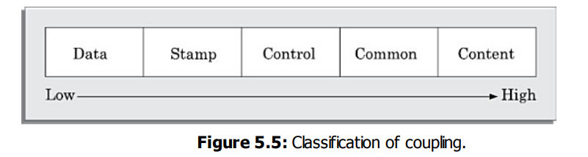
Data coupling: Two modules are data coupled, if they communicate using an elementary data item that is passed as a parameter between the two, e.g. an integer, a float, a character, etc.
Stamp coupling: Two modules are stamp coupled, if they communicate using a composite data item such as a record in PASCAL or a structure in C.
Control coupling: Control coupling exists between two modules, if data from one module is used to direct the order of instruction execution in another.
Common coupling: Two modules are common coupled, if they share some global data items.
Content coupling: Content coupling exists between two modules, if they share code.

LAYERED ARRANGEMENT OF MODULES

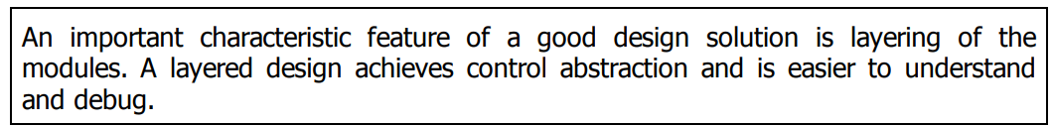
In a layered design, the top-most module in the hierarchy can be considered as a manager that only invokes the services of the lower-level module to discharge its responsibility.
Understanding a layered design is easier since to understand one module, one would have to at best consider the modules at the lower layers (that is, the modules whose services it invokes).
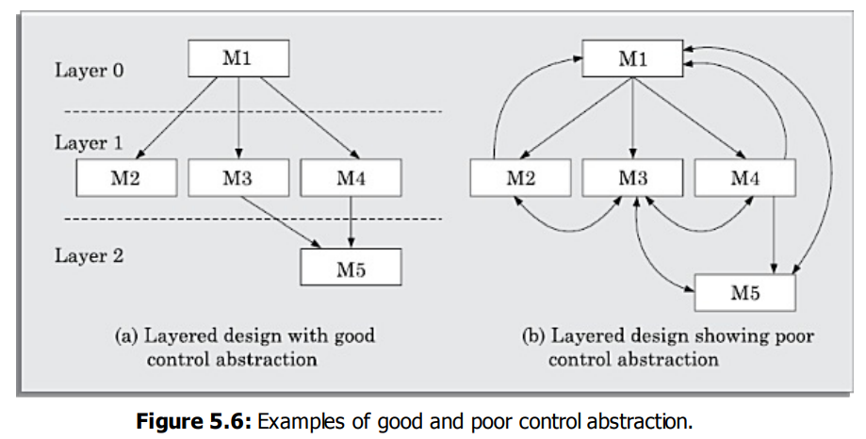
In the following, we discuss some important concepts and terminologies associated with a layered design:
Superordinate and subordinate modules: In a control hierarchy, a module that controls another module is said to be superordinate to it. Conversely, a module controlled by another module is said to be subordinate to the controller.
Visibility: A module B is said to be visible to another module A, if A directly calls B. Thus, only the immediately lower layer modules are said to be visible to a module.
Control abstraction: In a layered design, a module should only invoke the functions of the modules that are in the layer immediately below it.
Depth and width: Depth and width of a control hierarchy provide an indication of the number of layers and the overall span of control respectively.
Fan-out: Fan-out is a measure of the number of modules that are directly controlled by a given module. In Figure 5.6(a), the fan-out of the module M1 is 3. A design in which the modules have very high fan-out numbers is not a good design.
Fan-in: Fan-in indicates the number of modules that directly invoke a given module. High fan-in represents code reuse and is in general, desirable in a good design. In Figure 5.6(a), the fan-in of the module M1 is 0, that of M2 is 1, and that of M5 is 2.

APPROACHES TO SOFTWARE DESIGN
There are two fundamentally different approaches to software design that are in use today— function-oriented design, and object-oriented design.
Though these two design approaches are radically different, they are complementary rather than competing techniques.
- Function-oriented Design
The following are the salient features of the function-oriented design approach:
Top-down decomposition: A system, to start with, is viewed as a black box that provides certain services (also known as high-level functions) to the users of the system.
For example, consider a function create-new-library me mbe r which essentially creates the record for a new member, assigns a unique membership number to him, and prints a bill towards his membership charge. This high-level function may be refined into the following subfunctions:
• assign-membership-number
• create-member-record
• print-bill Each of these subfunctions may be split into more detailed subfunctions and so on.
Centralised system state: The system state can be defined as the values of certain data items that determine the response of the system to a user action or external event.
For example, in the library management system, several functions such as the following share data such as member-records for reference and updation:
• create-new-member
• delete-member
• update-member-record
- Object-oriented Design
In the object-oriented design (OOD) approach, a system is viewed as being made up of a collection of objects (i.e. entities). Each object is associated with a set of functions that are called its methods.
Objects can also be considered as instances of abstract data types (ADTs).
There are, in fact, three important concepts associated with an ADT—data abstraction, data structure, data type.
Data abstraction: The principle of data abstraction implies that how data is exactly stored is abstracted away. This means that any entity external to the object (that is, an instance of an ADT) would have no knowledge about how data is exactly stored, organised, and manipulated inside the object.
Data structure: A data structure is constructed from a collection of primitive data items.
Data type: A type is a programming language terminology that refers to anything that can be instantiated. For example, int, float, char etc., are the basic data types supported by C programming language. Thus, we can say that ADTs are user defined data types.
AGILITY
Agility – Todays buzz word – means Quick respond to changes

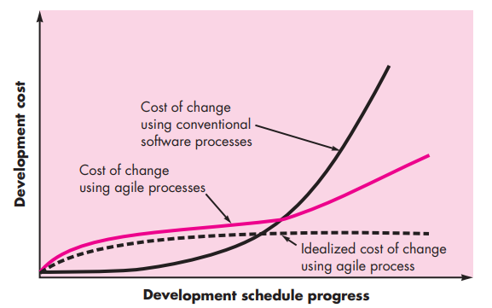
Agility Process
- Agility Principles
- Human Factors
- Agility Principles
The Agile Alliance defines 12 agility principles for those who want to achieve agility
- Our highest priority is to satisfy the customer through early and continuous delivery of valuable software.
- Welcome changing requirements, even late in development. Agile processes harness change for the customer’s competitive advantage.
- Deliver working software frequently, from a couple of weeks to a couple of months, with a preference to the shorter timescale.
- Business people and developers must work together daily throughout the project.
- Build projects around motivated individuals. Give them the environment and support they need, and trust them to get the job done.
- The most efficient and effective method of conveying information to and within a development team is face-to-face conversation.
- Working software is the primary measure of progress.
- Agile processes promote sustainable development. The sponsors, developers, and users should be able to maintain a constant pace indefinitely
- Continuous attention to technical excellence and good design enhances agility.
- Simplicity—the art of maximizing the amount of work not done—is essential.
- The best architectures, requirements, and designs emerge from self– organizing teams.
- At regular intervals, the team reflects on how to become more effective, then tunes and adjusts its behavior accordingly

- Human Factors
Proponents of agile software development take great pains to emphasize the importance of “people factors.”
If members of the software team are to drive the characteristics of the process that is applied to build software, a number of key traits must exist among the people on an agile team and the team itself.
Competence. In an agile development (as well as software engineering) context, “competence” encompasses innate talent, specific software-related skills, and overall knowledge of the process that the team has chosen to apply.
Common focus. Although members of the agile team may perform different tasks and bring different skills to the project, all should be focused on one goal—to deliver a working software increment to the customer within the time promised.
Collaboration. Software engineering (regard
ess of process) is about assessing, analyzing, and using information that is communicated to the software team.
Decision-making ability. Any good software team (including agile teams) must be allowed the freedom to control its own destiny.
Fuzzy problem-solving ability. Software managers must recognize that the agile team will continually have to deal with ambiguity and will continually be buffeted by change.
Mutual trust and respect. The agile team must become a “jelled” team. A jelled team exhibits the trust and respect that are necessary to make them “so strongly knit that the whole is greater than the sum of the parts”
Extreme Programming (XP)
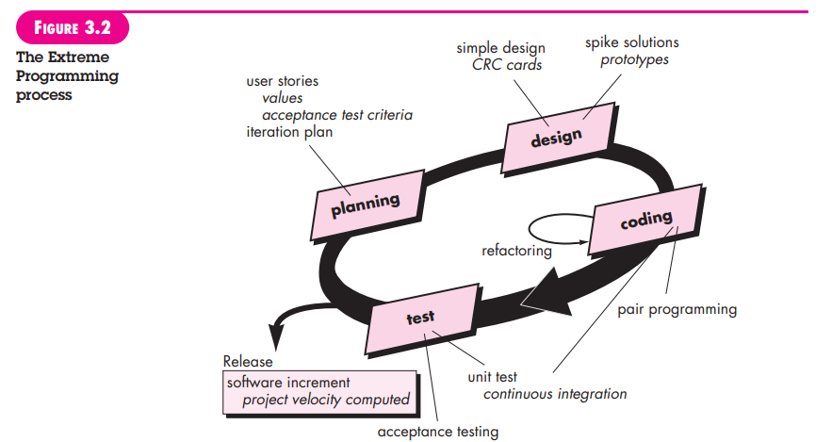
OTHER AGILE PROCESS MODELS
• Adaptive Software Development (ASD)
• Scrum
• Dynamic Systems Development Method (DSDM)
• Crystal
• Feature Drive Development (FDD)
• Lean Software Development (LSD)
• Agile Modeling (AM)
• Agile Unified Process (AUP)
SCRUM
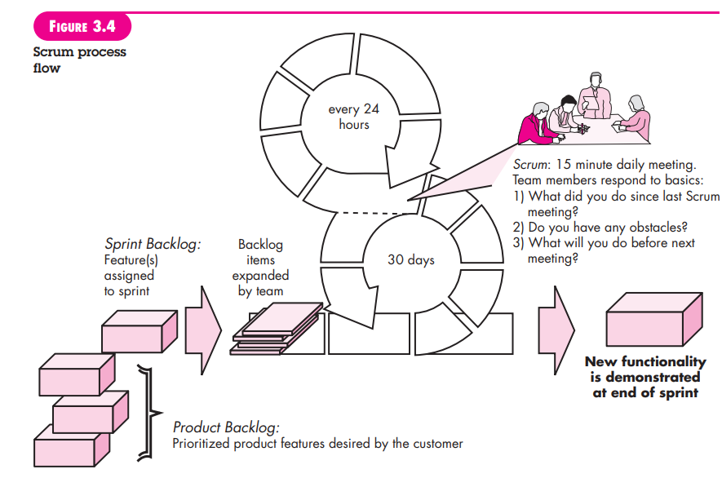
A TOOL SET FOR THE AGILE PROCESS
Agile alliance suggests some tools can have a benefit and that “agile teams stress using tools that permit the rapid flow of understanding
- Hiring tools - right people (hiring), team collaboration, stakeholder communication
- Collaborative and communication tools - Active communication, Pair Programming
- Project management tools - nurturing social interactions, graphs of tests created versus passed

FUNCTION-ORIENTED SOFTWARE DESIGN
OVERVIEW OF SA/SD METHODOLOGY
As the name itself implies, SA/SD methodology involves carrying out two distinct activities:
- Structured analysis (SA)
- Structured design (SD)
The roles of structured analysis (SA) and structured design (SD) have been shown schematically in Figure 6.1. Observe the following from the figure:
- During structured analysis, the SRS document is transformed into a data flow diagram (DFD) model.
- During structured design, the DFD model is transformed into a structure chart.
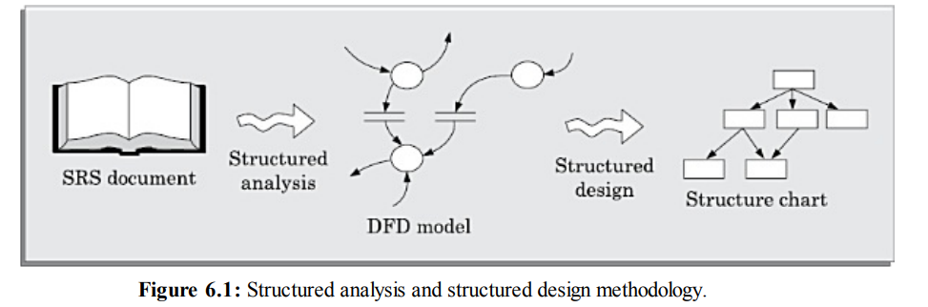
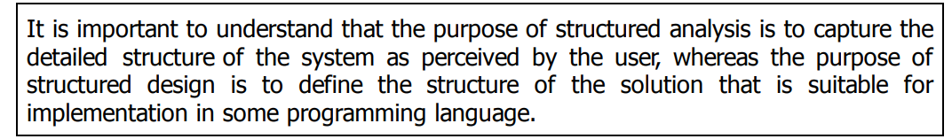
STRUCTURED ANALYSIS
The structured analysis technique is based on the following underlying principles:
- Top-down decomposition approach.
- Application of divide and conquer principle. Through this each highlevel function is independently decomposed into detailed functions.
- Graphical representation of the analysis results using data flow diagrams (DFDs).
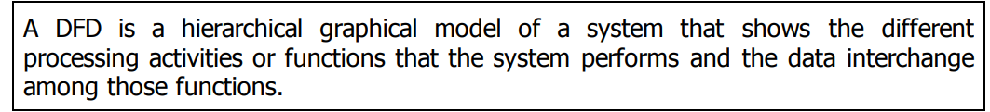
Data Flow Diagrams (DFDs)
The DFD (also known as the bubble chart) is a simple graphical formalism that can be used to represent a system in terms of the input data to the system, various processing carried out on those data, and the output data generated by the system.
Primitive symbols used for constructing DFDs
There are essentially five different types of symbols used for constructing DFDs. These primitive symbols are depicted in Figure 6.2.
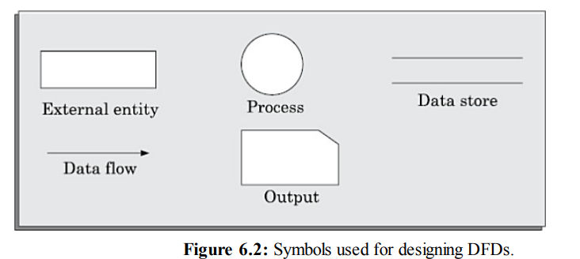
Function symbol: A function is represented using a circle. This symbol is called a process or a bubble. Bubbles are annotated with the names of the corresponding functions
External entity symbol: An external entity such as a librarian, a library member, etc. is represented by a rectangle.
Data flow symbol: A directed arc (or an arrow) is used as a data flow symbol. A data flow symbol represents the data flow occurring between two processes or between an external entity and a process in the direction of the data flow arrow.
Data store symbol: A data store is represented using two parallel lines. It represents a logical file. That is, a data store symbol can represent either a data structure or a physical file on disk.
Output symbol: The output symbol i s as shown in Figure 6.2. The output symbol is used when a hard copy is produced
Synchronous and asynchronous operations
If two bubbles are directly connected by a data flow arrow, then they are synchronous. This means that they operate at the same speed. An example of such an arrangement is shown in Figure 6.3(a).
Here, the validate-number bubble can start processing only after t h e read-number bubble has supplied data to it; and the read-number bubble has to wait until the validate-number bubble has consumed its data.
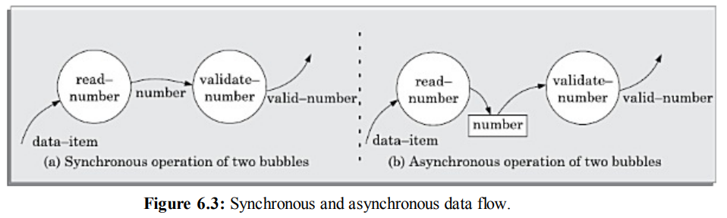
Data dictionary
DEVELOPING THE DFD MODEL OF A SYSTEM
A DFD model of a system graphically represents how each input data is transformed to its corresponding output data through a hierarchy of DFDs.
- The top level DFD is called the level 0 DFD or the context diagram. This is the most abstract (simplest) representation of the system (highest level).
- It is the easiest to draw and understand.
- At each successive lower level DFDs, more and more details are gradually introduced.
- To develop a higher-level DFD model, processes are decomposed into their subprocesses and the data flow among these subprocesses are identified.
Context Diagram
- The context diagram is the most abstract (highest level) data flow representation of a system. It represents the entire system as a single bubble.
- The bubble in the context diagram is annotated with the name of the software system being developed (usually a noun).
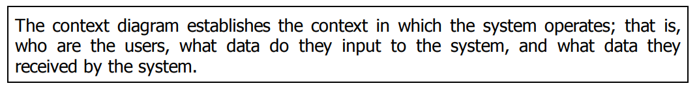
Generate DFD for Tic-Tac-Toe Computer Game
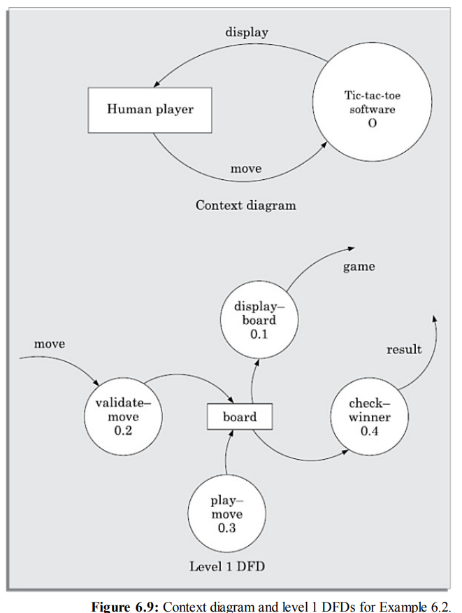

Level 1 DFD
The level 1 DFD usually contains three to seven bubbles. That is, the system is represented as performing three to seven important functions. To develop the level 1 DFD, examine the high-level functional requirements in the SRS document.
Example 6.5 (Personal Library Software) Perform structured analysis for the personal library software of Example 6.5.
The context diagram is shown in Figure 6.15.
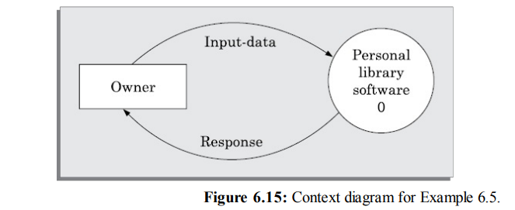
The level 1 DFD is shown in Figure 6.16.
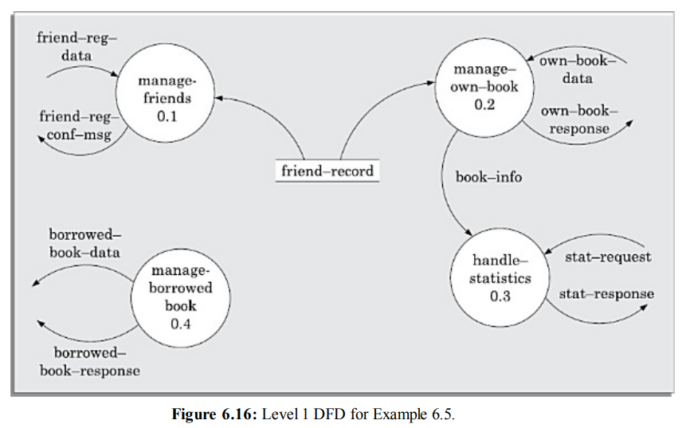
The level 2 DFD for the manageOwnBook bubble is shown in Figure 6.17.
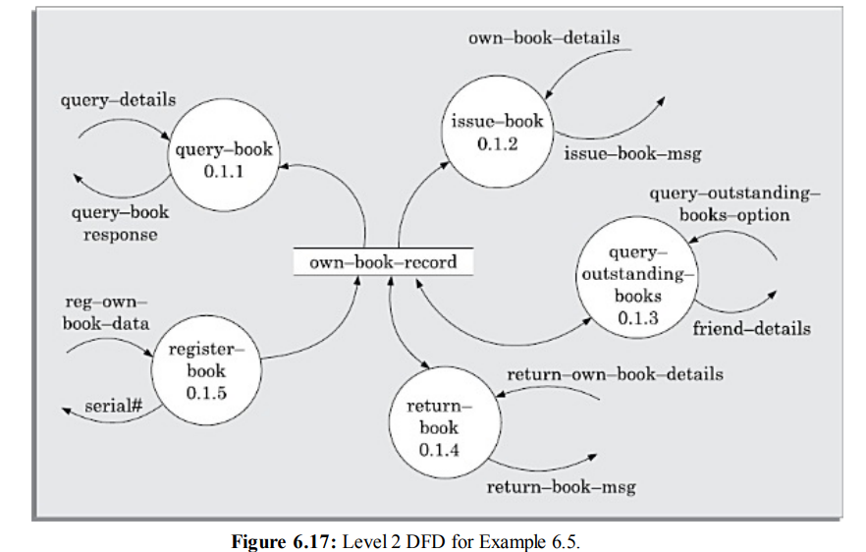
STRUCTURED DESIGN
The aim of structured design is to transform the results of the structured analysis (that i s, the DFD model) into a structure chart.
A structure chart represents the software architecture. The various modules making up the system, the module dependency (i.e. which module calls which other modules), and the parameters that are passed among the different modules.
The basic building blocks using which structure charts are designed are as following:
Rectangular boxes: A rectangular box represents a module. Usually, every rectangular box is annotated with the name of the module it represents.
Module invocation arrows: An arrow connecting two modules implies that during program execution control is passed from one module to the other in the direction of the connecting arrow.
Data flow arrows: These are small arrows appearing alongside the module invocation arrows. The data flow arrows are annotated with the corresponding data name
Library modules: A library module is usually represented by a rectangle with double edges.
Selection: The diamond symbol represents the fact that one module of several modules connected with the diamond symbol is invoked depending on the outcome of the condition attached with the diamond symbol.
Repetition: A loop around the control flow arrows denotes that the respective modules are invoked repeatedly.
An example of a properly layered design and another of a poorly layered design are shown in Figure 6.18.
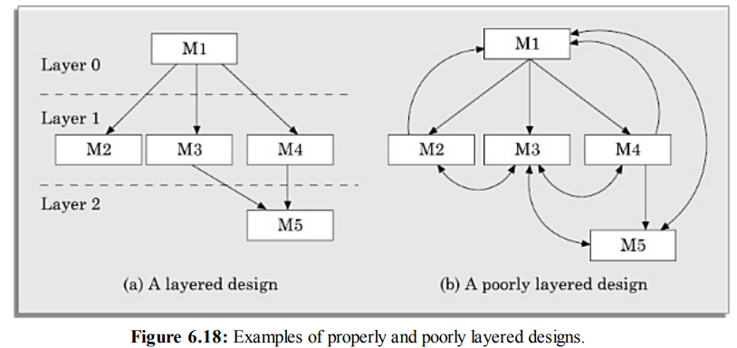
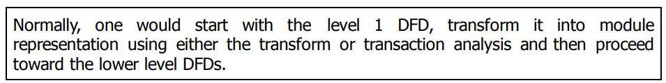
Example 6.7 Draw the structure chart for the tic-tac-toe software of Example 6.2
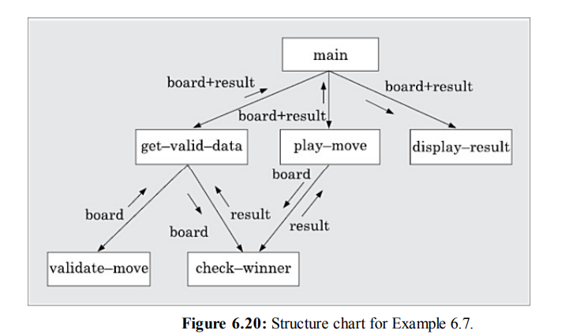
DETAILED DESIGN
During detailed design the pseudo code description of the processing and the different data structures are designed for the different modules of the structure chart.
These are usually described in the form of module specifications (MSPEC). MSPEC is usually written using structured English.
The MSPEC for the non-leaf modules describe the different conditions under which the responsibilities are delegated to the lower-level modules.
DESIGN REVIEW
After a design is complete, the design is required to be reviewed.
The review team usually consists of members with design, implementation, testing, and maintenance perspectives, who may or may not be the members of the development team.
Normally, members of the team who would code the design, and test the code, the analysts, and the maintainers attend the review meeting,
The review team checks the design documents especially for the following aspects:
Traceability: Whether each bubble of the DFD can be traced to some module in the structure chart and vice versa.
Correctness: Whether all the algorithms and data structures of the detailed design are correct
Maintainability: Whether the design can be easily maintained in future.
Implementation: Whether the design can be easily and efficiently be implemented

